La Siesta | HOME / ABOUT US / MENU / CONTACT
La Siesta
Fresh ingredients and simply delicious cuisine

Seasoned to perfection
Aperiam eaque ipsa quae ab illo inventore veritatis et quasi architecto beatae vitae dicta sunt explicabo nemo enim ipsam voluptatem quia voluptas sit aspernatur aut odit aut fugit sed quia consequuntur magni dolores eos qui ratione voluptatem sequi nesciunt neque.


Daily specials
02/29/2023
 | Market salad  Architecto beatae vitae dicta sunt | 10$
 | Roasted salmon  Porro quisquam est qui dolorem | 10$
 | Hanger steak  Illo inventore veritatis et quasi | 25$
 | Cheeseburger  Nesciunt neque porro quisquam est | 35$

Your event in our restaurant
Sed ut perspiciatis unde omnis iste natus error sit voluptatem accusantium doloremque laudantium totam rem aperiam eaque ipsa quae ab
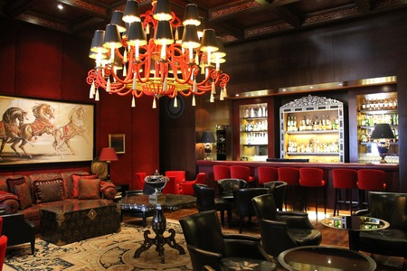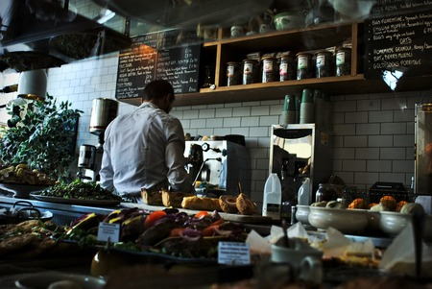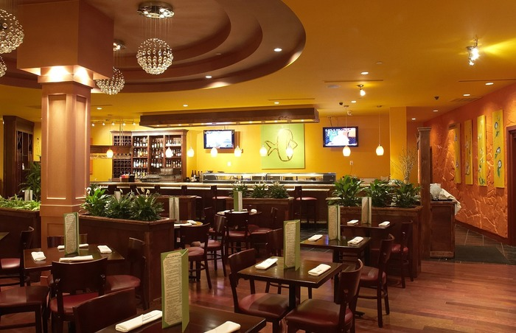

Get your reservation now
Monday - Friday 8:00am - 8:00pm
Saturday: 12:00am - 8:00pm
La Siesta
ST110 #86A Boeung Kork I Khan Toul Kork

Power by Associate Student

Date 5th July 2024

